Multimedia Design and Communication

Class X

Business Academy Aarhus

Project 1.2: Content

<http://www.leanderdesigns/magazine/grid.html>

Assignment by: Florine Ama Hofmann

**Teachers:**

Maria Louise Bendixen, Teamleader, Business and Communications

Jan Skovgård Jensen, Interaction Development

Sergio da Luz Benros, Design

**word count**: 2828

**About**

**“the grid”** is an online lifestyle magazine, highlighting the everyday student life and exploring the ways of improvement throughout the experience. **“the grid”** is a magazine designed by students for students.

In this synopsis I will describe in detail, how this magazine came about, how I defined the target audience, to set the overall theme of the magazine, the research I’ve done to create valuable content for the reader and the main idea behind the magazine.

**Target audience**

Based on our assignment, my main target audience were students, which meant that I my main concern in the beginning was to define the term and age group in order to get a clearer picture of who I would be researching for and speaking to.

The Oxford Dictionary describes a student as “someone who is studying at a university or other place of higher education; a school pupil” and after a quick google search I found out that the average European student age was 22.

This meant that I could use this as my point of origin but to get further insight into particular students interest it was necessary to create a small online survey in order to find out what the majority of students would be interested in reading about.

**The Survey**

*(*For the purpose of readability, I have written questions asked in *italics* and the keywords and bullet points, that I ended up choosing for my online magazine*,* in**bold lettering***)*

The survey was conducted via typeform.com and brought me to the following conclusions:

**27 students** participated in my survey, which was distributed with a link on several Facebook sites, inside the Business Academy Aarhus and outside.

* Out of the 27 participants, 15 were women and 12 men which calls for an even balance and would mean that my target group could include both sexes.
* The age group I had researched before was confirmed by my survey as the average student was indeed 22.
* When asked in an open question which kind of content the participant were looking forin a student online magazine an overwhelming amount had the same group of interest, which revolved around **finance control**, interconnected relationships, **studying** and **organising tips,** studentfashion, **quick meals**, parties, **affordable activities,** student sports. Some of the more specific requests revolved around certain studying topics, like the psychology within the university behaviour, self-marketing strategies for student jobs and how to write a perfect CV.
* When answering the multiple-choice question if the participants would rather read content on one specific area, like studying, *or* resemble examples of overall student life, the majority of 68% surprisingly chose the latter one, which was unexpected to me but goes to show that surveys are indeed a necessary tool in order to truly identify the target group and potential readers.
* The answer to the open question on what a student magazine should look like, answers included words like: **sophisticated**, easy, pretty, **smart**, **attainable**, nice, **relatable**, **fun**, **inspiring**
* In the last question, I asked what the students wouldn’t want in a student magazine, to which many answered: **bad layout**, **boring articles**, **obvious tips** and **generalisations**.

**The Content**

Based on the research I have conducted, I decided that the best way to cater to most students needs was to focus on creating a lifestyle magazine rather than a topic magazine, in order to create a space that all students could get value out of. I was of the opinion that the content suggestions of my target audience were accurate and valid, which is why my next step was to filter and curate the suggestions and preferences of my target audience in order to create an authentic platform; (find above in **bold letterin**g).

I decided to select 4 different focus categories, that had even ranking in the magazine.

**The Categories**

*(*For the purpose of readability, I have written the articles, that I ended up choosing for my online magazine*,* in**bold lettering***)*

Based on the percentage of suggestions by my survey participants I went for the following categories:

* Studying

In this category I wanted to give valuable tips and tricks on how to improve studying performance with articles like “How to get straight A’s”, “how to cram for an exam”, “The dos and don’ts of an all-nighter” and “**Tips on** **how to avoid procrastination”**.

* Food Recipes

This category leaves a lot of room for imagination. I decided to focus on nutritious and quick meals with ingredients that wouldn’t cost too much. I had ideas for “one pot pasta”, **“risotto convex”,** “homemade Gatorade”, **“healthy brain breakfast”,** **“study snacks”** and “the midnight craving solution”.

* Finance Control

This was a topic where I wanted to focus on areas students usually spend a lot of money on and struggle to cut down in. An obvious choice here was **grocery shopping** as this is where most students could apply more mindful spending, but I also had tips in mind like: “how to grow your savings account”, “10 financial management mistakes we all make”, “How to keep track of your finances”, “10 side hustles everyone could do”, “Map through the Danish tax system” and **“5 Step budgeting Checklist”.**

* General Student lifestyle

I wanted this category to could include events and **life hacks** as well as fun challenges and party recipes, which would therefore give me bit of **editorial freedom** without having to compromise the overall theme of the magazine.

**The Articles**

When it comes to the captions of the articles, I focused on making the title aspirational without compromising its integrity by putting point into the article that, if followed strictly, could lead to promised outcome (e.g Anti-Procrastination Hacks). It was important to me to make the article to sound interesting from the get go, without portraying false hopes.

When it comes to the writing style, I tried to keep it simple, spoke in direct speech and usually addressed the students with you and referred “the grid’s” perspective as we, in order to make it less formal and make the reader feel like I am speaking directly to them.

To create a “newspapery” feel, I always put 2 articles next to each other, keeping in mind that the readers eye would wonder to the left article first, which is why I always put the more relevant article on the left side.

To split up the article in order to make it more digestible for the reader, I made it a point to include either pictures or bullet points or both in each article and split the paragraphs for a better reading experience.

To make it easier for the reader to identify the nature of the article, I put bullet point tags like “Recipe” or “Tips” on top of each article.

I used the Arial font, since that is known to be the one of the easiest and most comfortable to read.

## Healthy Brain Breakfast:

## Within the eat section I wanted to provide options that, if eaten daily, would still have enough nutritional value in order to be considered healthy. Having grown up with a nutritionist as a mother, I drew from my own knowledge about nutrition, which is why fact sources are not included in this section.

## For the breakfast bowl, I chose interchangeable ingredients, to be customised to each individual student’s need, be it regular, gluten free or vegan.

## Homemade Seasoned Popcorn

## A common study snack is usually a bag of crisps, a bar of chocolate or leftover cereal from the morning. None of these create nutritional value.

## With the seasoned homemade popcorn, I wanted to create a study snack that wouldn’t spike and drop the blood sugar level (the way that sugary snacks usually do), which is why I opted for a salty snack, that would still provide a few health benefits without compromising the satisfaction of a regular snack.

## Risotto Convex

## I created this recipe to give a bullet proof option for busy study periods, with ingredients that included the daily dose of protein, carbohydrates and greens.

## How to Avoid Procrastination

## Procrastination is a topic that speaks to each and every student and is an inevitable part of student life. I wrote this article because I thought it would be interesting to explore the options of avoiding procrastination in the first place and whether there were life hacks out there that could be helpful to everyone.

## Sustainable Solutions

## This post is supposed to introduce the thought of sustainability within the student life to my target audience. Since environmental change is a very accurate topic, especially amongst students, I thought it would be relevant enough to put into a context of the school related items that we could overthink.

## Budgeting Checklist

## This simple checklist is supposed to kick-start a student’s mind set on financial balance, without overwhelming them with too many “commandments”. It was important to me to provide tips where the student could ease into a realistic habit of financial stability, while keeping the topic light by providing personal titbits.

## 

## The Ultimate Grocery Shopping Guide for Students

## Like stated above, grocery shopping is considered the biggest obstacle when it comes to living within a budget, as food is usually something hard to compromise on. I created the shopping guideline in order for new students to know what a regular shopping list could look like and encourage them to look into cooking simple recipes instead of opting for the good ol’ “pasta with ketchup option”.

**Anti-hangover Cocktail**

This article was written to lighten up the overall mood, honouring my target audiences wish for fun content, while still creating a something of value.

Furthermore, finding the work/play balance within your student life is a task most students are faced with at some point during their studies and creating a fun delusional solution to this problem is sometimes all we need.

## 10 Ways to Take a Break

## With the student lifestyle magazine, I wanted to create a realistic as well as a holistic approach to being a student, which not only consists of studying and partying, but of taking a break, identifying stress factors, taking care of your mental health and exploring other interest and hobbies.

## According to the World Health Organisation (source in appendix below), suicide among 15-29 year olds is the second leading cause of death worldwide, which includes a great number of students and makes this article relevant to my specific target group.

## This article is supposed to highlight the necessity of balance and provide useful inspiration to becoming a well-rounded person.

## The Name

## Thinking about the different themes and categories I have created, I realised that most of my topics revolved around how-tos, especially for people new in the field of university, that requires a certain level of endearing inexperience. I decided to name the website “the grid”, which represents the abbreviation of the phrase “grown kid” and on a broader level, represents a framework, an essential supporting structure not unlike the structure of an educational facility.

## This grid structure will later also be reflected in the layout of the online magazine.

## The Logo

## For the logo, I considered the wishes of my target group to match the website in being simple, sophisticated, smart, and relatable. I used one font (Garamond) and decided to stick to small letters to resemble the “kid”, increasing the letter “g” in order to imply the “grown”.

## I chose the Garamond for the specific reason that the small “g”, looks like a pair of glasses, which I found to be very fitting, considering the demographic.

## I also made sure to create the logo as a vector entity, in order to make it responsive in the code later on.

## The Website

## After the logo and articles were created, I started sketching out ideas for the layout of the online magazine.

## My bullet points for that were:

## Correlation with the logo.

* My target groups request to be **smart, easy to navigate sophisticated**, **attainable**, **relatable**, and **inspiring.**

## The Sketches

Here you can see the sketching process I went through:

## ../../../../Downloads/IMG_5610.JPG../../../../Downloads/IMG_5611.JPG../../../../Downloads/IMG_5612.JPG

## First Sketch- trying out grids

## Brainstorming

## Final sketch – the one one the bottom

**The Photoshop Prototype**

Here you can see the outcome of the Photoshop prototype I after the last sketch on paper:

**This is the prototype for the main landing page.**

In the actual website, I ended up changing the navigation bar, added to the categories and had to adjust the round look of the logo due to the lack of my coding skills.

**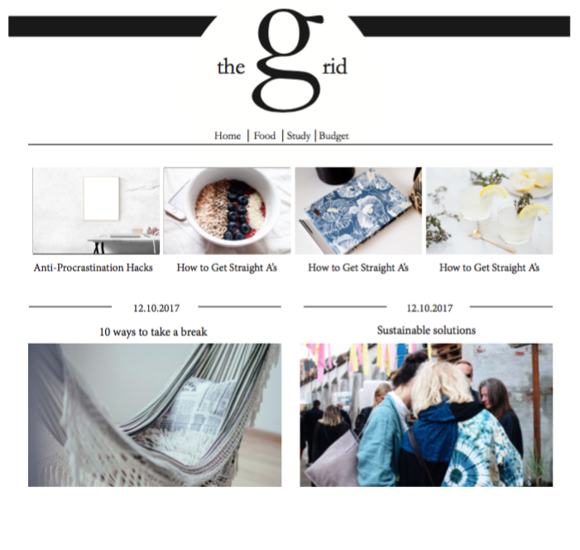**

**This is the prototype for the individual article pages.**

In the actual website, I ended up changing the layout of the articles from one column into 2, in order to give it more of a grid look and to make it feel more like a newspaper. I also decided to exchange the date with relevant bullet point tags that could help the student navigate better through the content in order to find what they are looking for faster.

**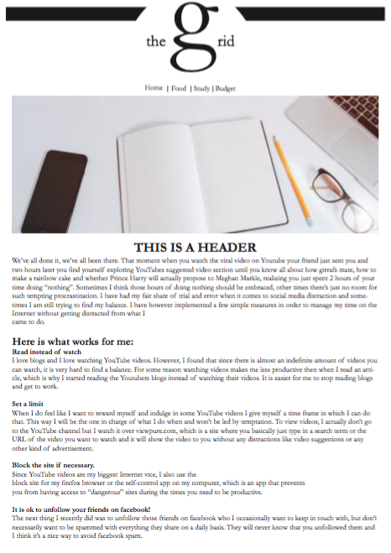**

**The Design**

* In order to establish the *correlation* with the logo, which in its form is round and not “grid-like”, I wanted the articles to be displayed in a “grid-like” manner, that would make it easy to navigate through the website. Like stated above it was important for me to create the grid structure as it represents not only the meaning of the word but theframework of university, which is arguably the essential supporting structure before going out into the “real world”.
* The *sophisticated* look I tried to establish with a sophisticated black and white colour scheme, strict lines in the layout with lots of white space to in order to focus on the substance, navy links and demanding a pictures colour scheme requirement of light, crème mixed dark rich colors like black, dark green, or dark blue. Another thing that helped to create sophistication was alignment throughout the website. Besides creating lines that align with each other in either a straight or triangular shape, I made sure that the pictures where on the same height level, and balanced out round and square elements.
* The *inspiring* part was meant to be achieved by the aspirational pictures, of which about 80% I took myself. Furthermore, the pictures were supposed to portray a sense of aspirational community that the student could identify with and strive towards.
* For the *attainable* and *relatable* part, I wanted to a create a newspaper like feeling, by providing 2 columns with 2 different topics both at eye height.

When I think about how the design can help communicate the content and earn my target groups attention, I go back to the survey I did in the beginning of the project, which was the base of all my design decisions. Due to implementing the participants wishes in true form I one could argue that this aspect will also ear their interest.

Furthermore, I kept the website content as well as the design simple and classic in its form which, through that, maintains a certain element of niche that might make it more appealing to the target audience.

**The Code**

Reflecting on my coding experience, I have to say that I struggled and learned in equal amounts.

I used a basic HTML code system and created one html file for every page with its own css styling code.

I used flexbox and float elements and spent a significant amount of research in order to code the website true to the Photoshop prototype.

I added social media buttons at the end and made the website responsive to the best of my abilities.

The most difficult thing to achieve was the 2 column layout and looking back, I still cannot decide whether the 1 column would have been a better and more comfortable choice for the reader.

**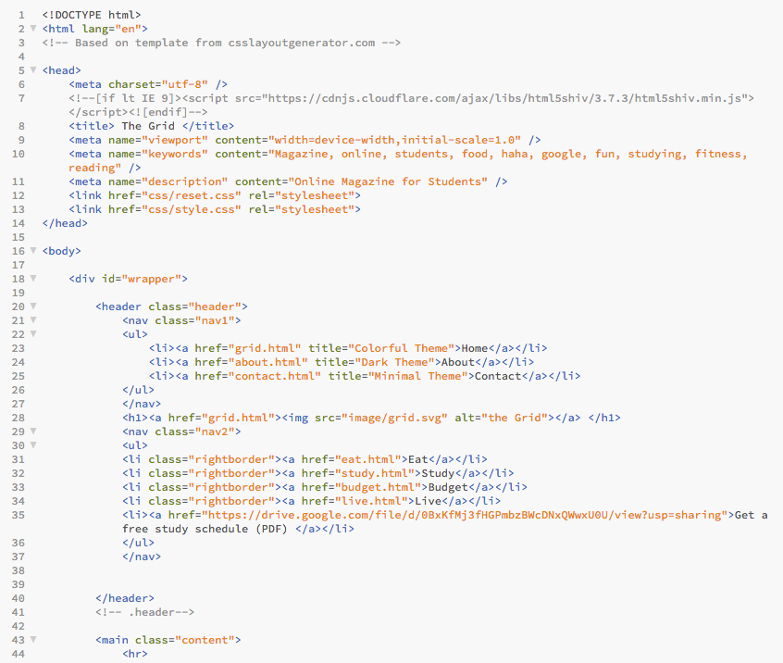**

**Trello**

When using Trello, an online organising app that helps with keeping track of all your task, I started with the approach of doing a week by week schedule for my tasks, which did not work as well as I would have hoped. I found myself more often than not with either having finished more tasks than planned or not enough, which the accuracy of the lists I made.

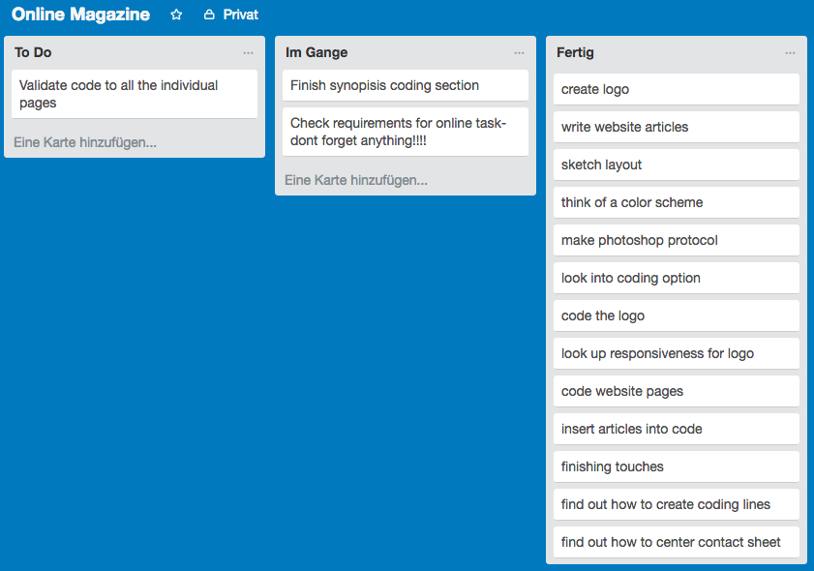

Throughout the rest of the time I used Trello merely as a checklist system, which worked satisfyingly well, as I could see my pile of to-dos shrinking as I went along making sure to reasonable in my time management.

**The Conclusion**

Besides this one doubt about whether I should have used 2 columns or one, I appreciate the experience of having worked on a project by myself, which enabled me to identify my strengths, weaknesses and limits within each of the subject areas.

**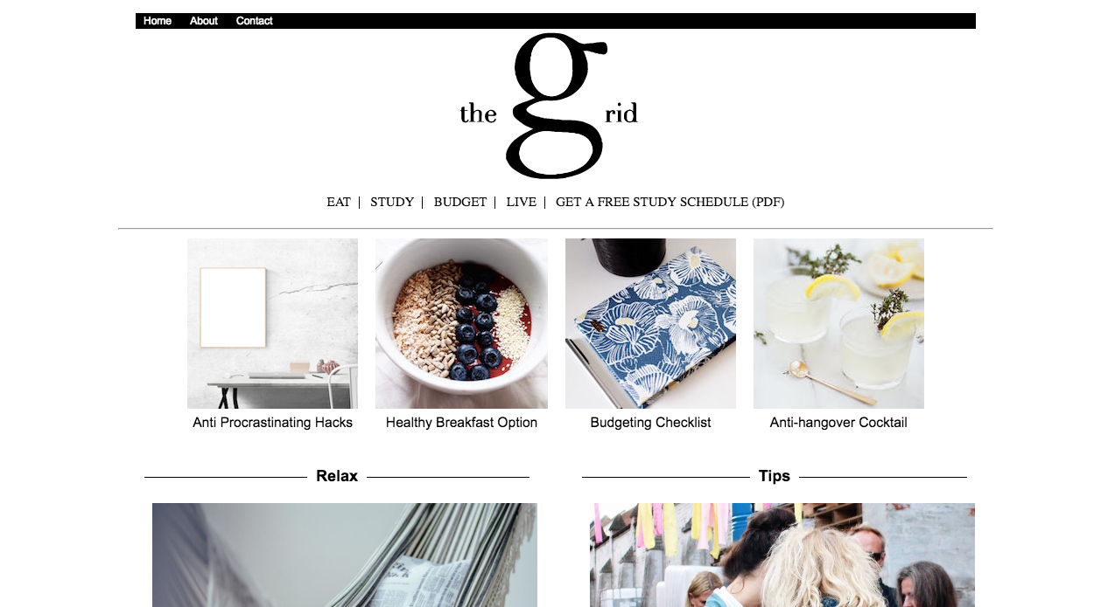**

**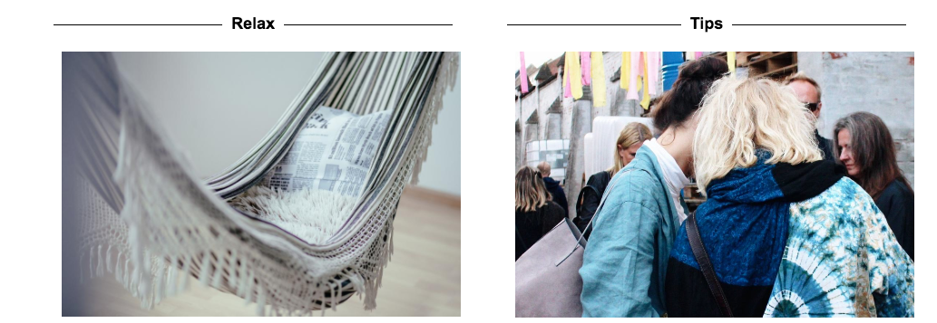**

**Appendix**

**Free Study Schedule**

[**https://drive.google.com/file/d/0BxKfMj3fHGPmbzBWcDNxQWwxU0U/view**](https://drive.google.com/file/d/0BxKfMj3fHGPmbzBWcDNxQWwxU0U/view)

**Anti-Procrastination hacks**

[**http://viewpure.com/**](http://viewpure.com/)

[**https://addons.mozilla.org/de/firefox/addon/blocksite/**](https://addons.mozilla.org/de/firefox/addon/blocksite/)

[**https://selfcontrolapp.com/**](https://selfcontrolapp.com/)

[**http://www.theguardian.com/commentisfree/2014/may/14/sleep-life-sleeplessness-blue-light-computers-early-death**](http://www.theguardian.com/commentisfree/2014/may/14/sleep-life-sleeplessness-blue-light-computers-early-death)

[**http://justgetflux.com/**](http://justgetflux.com/)

**Sustainable Solutions**

[**http://www.zerowastehome.com/2011/09/how-to-get-started/**](http://www.zerowastehome.com/2011/09/how-to-get-started/)

**Budgeting Checklist**

[**http://wally.me/**](http://wally.me/)

**Anti-hangover Cocktail**

[**http://www.farmersgin.com/**](http://www.farmersgin.com/)

**10 Ways to take a break**

[**http://fave.co/2kvIuUc**](http://fave.co/2kvIuUc)

[**http://fave.co/2kH1bGM**](http://fave.co/2kH1bGM)

**General:**

**http://www.who.int/mental\_health/prevention/suicide/suicideprevent/en/**